Market Breadth · Michael J. Stevenson, CAIA
Beneath the Index
The S&P 500 sits just 1.4% from its all-time high, yet three out of five of S&P 500 companies are more than 20% below theirs.
As of close, 09/24/2026
Drawdown from ATH | Members | Share of index
10% or more | 428 | 85.1%
20% or more | 304 | 60.4%
50% or more | 87 | 17.3%

304 of the 503 members of the S&P 500 are in an individual bear market when measured against each company's own all-time high.
I. The Shape of the Damage
Exhibit 1
Distribution of drawdowns from all-time highs
Number of S&P 500 companies within each range. The single largest grouping has drawdowns between 10% and 20% below highs (within correction territory), short of bear market territory. The right hand side of the 20% line is what the index level doesn’t quite reflect.
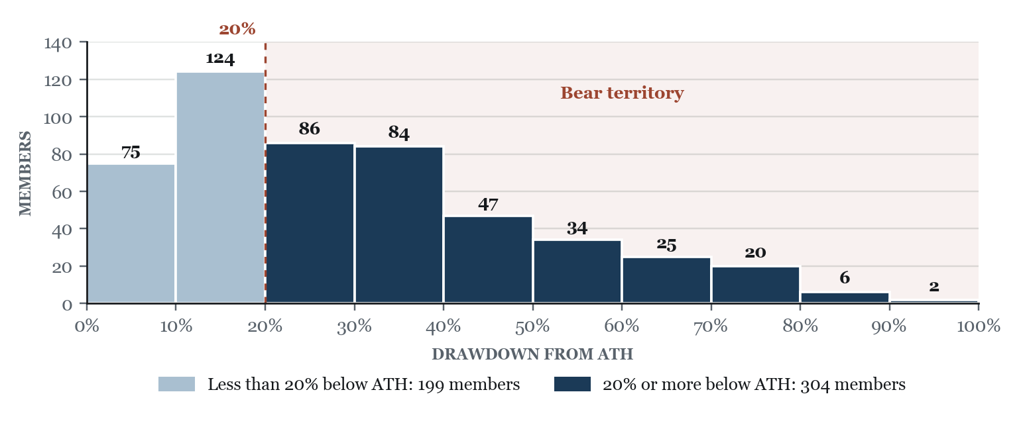
The S&P 500 is market cap-weighted, meaning the largest companies are the most impactful. What this also means is that a small number of large companies near all-time high levels can hold the index up while hundreds of smaller companies face drawdowns. Some notable names that have contributed significant growth over the last four years and still sit in the 0-10% below ATHs range include CRWD (−0.5%), AAPL (−2.4%), AMD (−2.6%), NVDA (−4.7%), META (−6.6%), PLTR (−7.6%) and MSFT (−9.9%).
Exhibit 2
Two reference highs, two different markets
The percentage of the S&P 500 at or beyond each drawdown threshold, measured against ATHs and against 52-week highs. The gap widens as the threshold deepens. At the 50% mark, the ATH lens finds five times as many names.
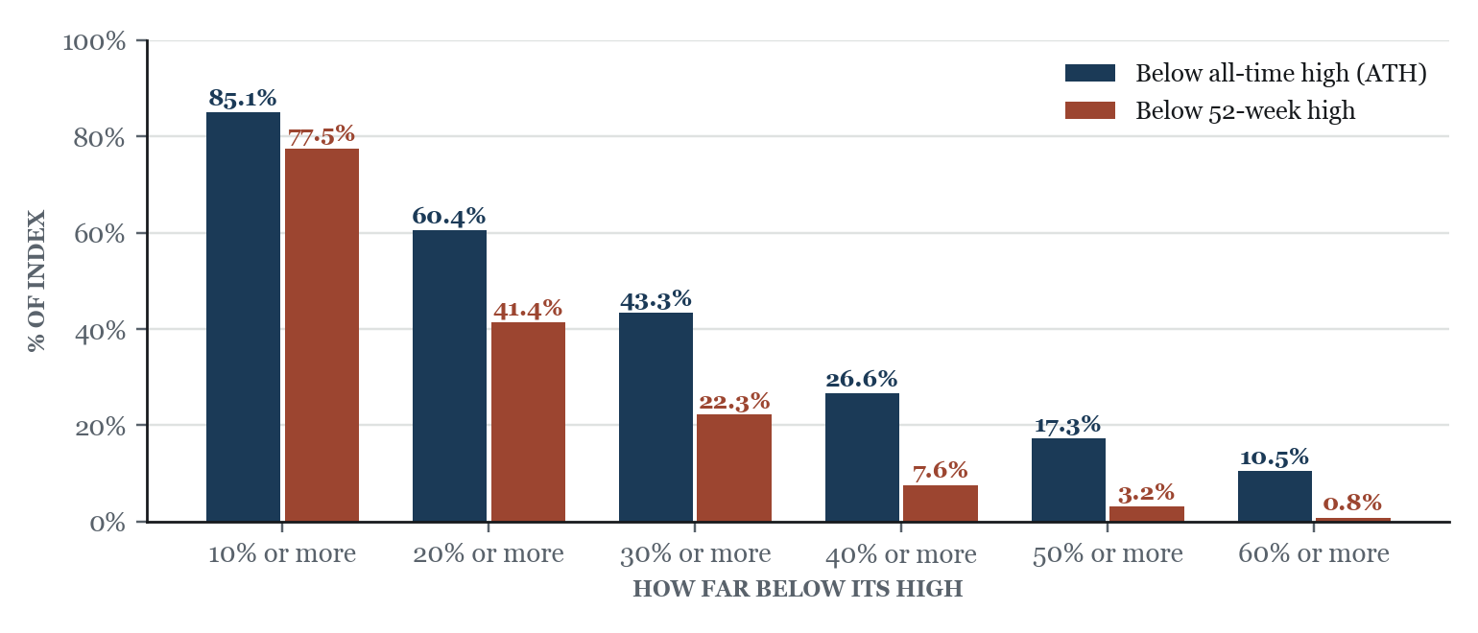
The 52-week view understates the damage because it resets every year. A stock that peaked years ago and has traded sideways since looks fine against a 52-week high but is still far below its ATH. This explains why 41.4% of members are 20% or more below a 52-week high and 60.4% are below their ATH. The gap widens at deeper thresholds (87 members are 50% or more below their ATH vs. 16 on a 52-week basis), which points to stocks that have stopped falling but never recovered.
Exhibit 3
How important is individual security selection?
All 503 constituents ranked from smallest to largest drawdown.
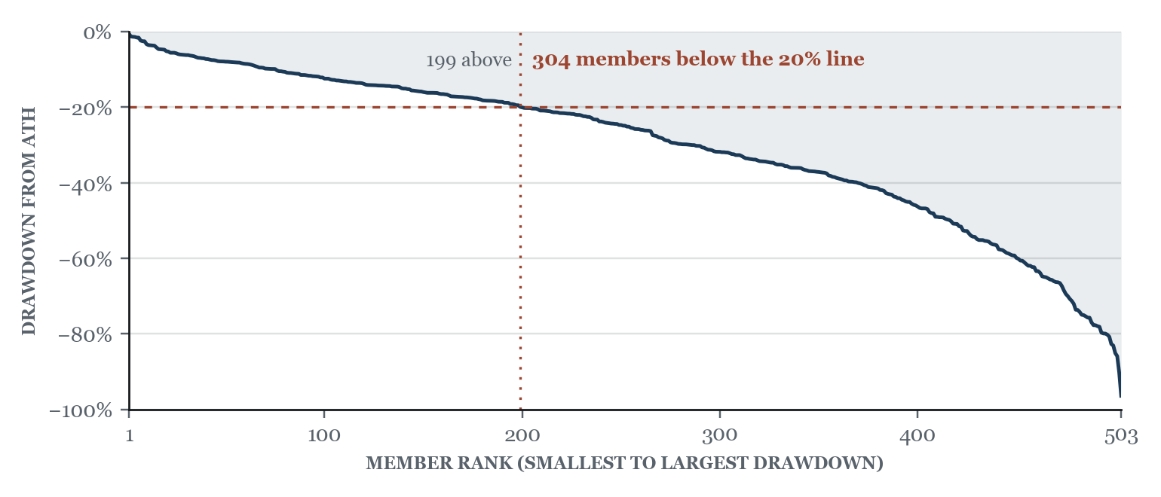
The median S&P 500 company is 24.9% below its ATH. The slope is gradual through the middle and steepens at the far end, where 28 members are more than 70% below. The S&P 500 points to broad weakness with a tail rather than a group of winners and a group of losers. This suggests individual security selection matters within a portfolio.
II. Where It Sits
Exhibit 4
Sector breadth against all-time highs
Share of each sector's members more than 20% below their ATH, with member count and sector median drawdown.
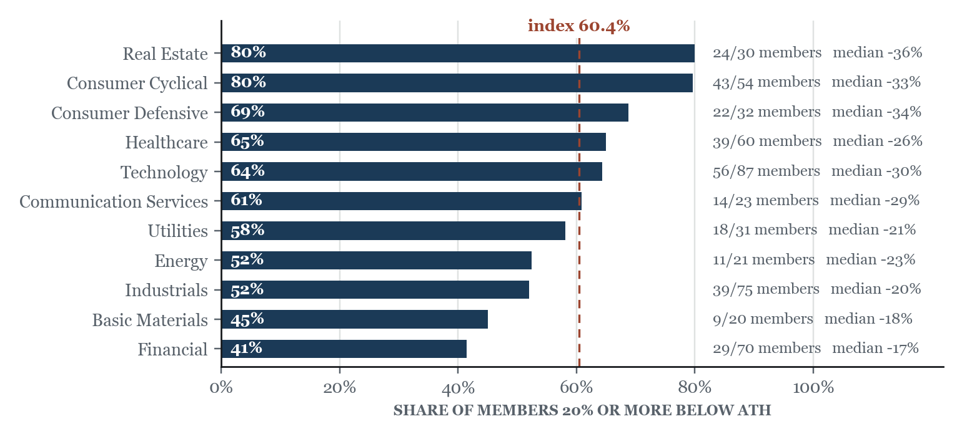
Real estate and consumer cyclical rank worst with 80% of each sector in a 20% or greater drawdown. Financials ranks best at 41% (median −17%). Real estate is rate sensitive, and the higher rate environment since 2022 pushed valuations down across the sector (median member 36% below ATH). 13 of 54 consumer cyclical members are 50% or more below their all-time highs. Technology is split. Chip and hardware names are near ATHs (NVDA −4.7%, AMD −2.6%, AAPL −2.4%), while software and services are deep in drawdowns (ADBE −65.6%, INTU −64.8%, ACN −56.0%).
Exhibit 5
The reference high changes the ranking
Like Exhibit 2, this compares both lenses. Real estate looks resilient on a 52-week view and worst in the index on an ATH view.
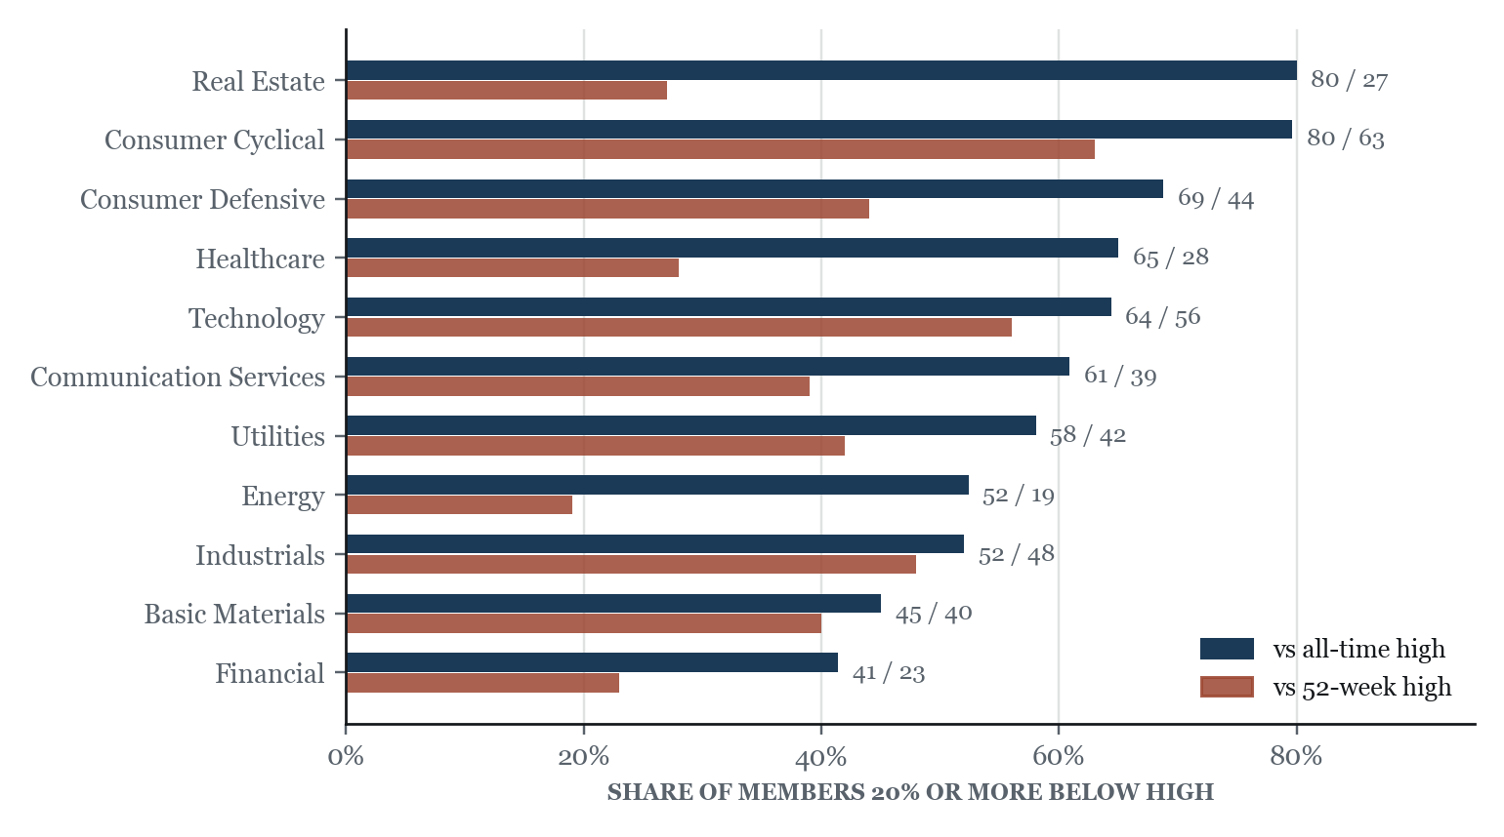
Real estate shows the difference best with 27% of members 20% or more below their 52-week high (80% on an ATH basis). Energy (19% vs. 52%) and health care (28% vs. 65%) show the same pattern. The two numbers are fairly close in technology (56% vs. 64%) and industrials (48% vs. 52%), where drawdowns are more recent and these sectors are still working through them.
III. Concentration
Exhibit 6
Cap-weighted against equal-weighted, since October 2022
The ratio of the market cap-weighted index to its equal-weighted counterpart.
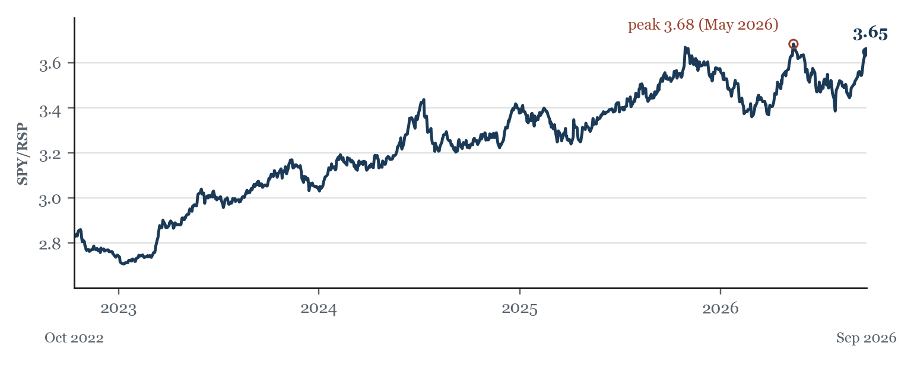
Since the start of the current bull market, the market cap-weighted to equal-weighted ratio has risen 29.2% to 3.65 from 2.82 in October of 2022. The cap-weighted index has outperformed the equal-weighted by a wide margin in this bull market. YTD, SPY (S&P 500) is +12.5% while RSP (equal-weight S&P 500) is +9.8%. This is the same story as Exhibits 1 through 5. The largest companies are lifting the index while the average company within the S&P 500 lags.
Sources
Exhibit 1: Yahoo Finance
Exhibit 2: Yahoo Finance, Finviz
Exhibit 3: Yahoo Finance
Exhibit 4: Yahoo Finance, Finviz
Exhibit 5: Yahoo Finance, Finviz
Exhibit 6: Alpha Vantage, SPY and RSP adjusted closes
ATH defined as the highest intraday price in each company's full available history.
For informational purposes only. Not investment advice.

